Spring Boot

**1.What is Spring Boot**

🡪 It is Spring Framework , It provides an easier and faster way to set up, configure, and run

It is a Spring module that provides the **RAD (Rapid Application Development)**

Spring Boot is the combination of **Spring Framework** and **Embedded Servers**.

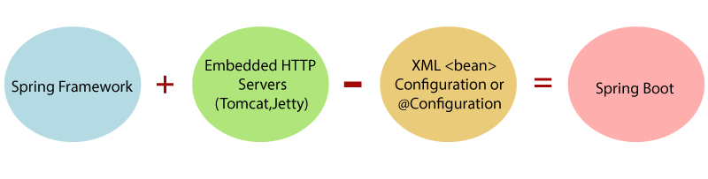

**2. How to create spring boot project?**

**🡪** We create spring boot project using

1. STS
2. Spring Initializer
3. CLI

**3. Advantages of spring Boot?**

🡪 Embeded Tomcat

No reqirement for XML Configuration

It provide endpoint using Actuator

Minimum configuration.

**4. Spring Boot follows a layered architecture?**

🡪 It contain defferent layer:-

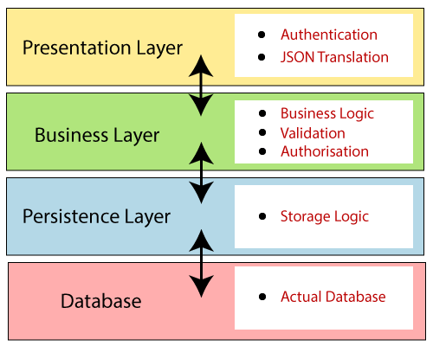

### 5. What are the Spring Boot key components?

Spring Boot auto-configuration.

Spring Boot starter POMs.

Spring Boot Actuators.

### 6. What is the starter dependency of the Spring boot module?

🡪 There are defferent deprndacies .. here are the most commonly used

- Data JPA starter.

- Spring Web

- Test

### 7. How does Spring Boot works?

🡪 The entry point of the spring boot application is the class that contains @SpringBootApplication annotation and the main method.

### 8. What does the @SpringBootApplication annotation do internally?

🡪 It Is the combination of @Configuration, @EnableAutoConfiguration, and @ComponentScan

### 9. What is the purpose of using @ComponentScan in the class files?

🡪 Spring Boot application scans all the beans and package

### 10. How does a spring boot application get started?

🡪 Spring Boot application must have a main method. This method serves as an entry point,

### 11. What are starter dependencies?

🡪 spring-boot-starter-web

### 12. What is Spring Initializer?

🡪 Spring Initializer is a web application that helps you to create an initial spring boot project structure

### 13. What is Spring Boot CLI and what are its benefits?

🡪 Spring Boot CLI is a command-line interface that allows you to create a spring-based java application

### 14. Is it possible to change the port of the embedded Tomcat server in Spring Boot?

🡪 Yes, By using the **server.port** in the **application.properties**.

### 15. Can we override or replace the Embedded tomcat server in Spring Boot?

🡪 Yes, using spring-boot-starter-jetty as a dependency

### 15. Can we disable the default web server in the Spring boot application?

🡪 Yes, configure **spring.main.web-application-type=none.**

### **16** What is the difference between RequestMapping and GetMapping?

### 17. What is Spring Actuator? What are its advantages?

🡪 It manage your application when you push it to production.

It provide the end point like

Health

Mapping

Beans

Info

http://localhost:8080/actuator/bean

### 18. How to enable Actuator in Spring boot application?

🡪 spring-boot-starter-actuator

**19. application.properties**

🡪 we can customize our application

**20. What is CrudeRepository?**

🡪 It provide JPA method like

findAll

findById

finaBy Name

we can also define custom methods.

findByNameStartWith

finadByNameEndWith

**21. How to create query**

@Query(value = "select * from hotel where id=:id",nativeQuery = **true**)

**22. DevTool dependency**

🡪 It restart the application automatically

**23. ResponseEntity**

🡪 If we want return status then we use ResponseEntity

**24. Spring Boot Security?**

🡪 add starter-security dependence

1. **What is microservices**

* Microservices are a software architectural in which application is divided into small, loosely coupled services that can be developed, deployed, and maintained independently.

**2. What are the main advantages of using microservices?**

**Flexibility:-**

Developer can use different programing languge,databse, technology for each service

**Team autonomy:**

Microservices enabled multiple team to work independantly

**Fault isolation:**

Issue in one service then do not effect on entire application

**2.How to Handel faulty Service?**

Using Circuit breaker we can handel

@CircuitBreaker(“ ”); 🡪 method level

So we need to add 3 dependancies

Actuator :- it provide the helth

Aop :- It provide matrix of actuator

Resilianc4j : it implement fault-tolerant strategies

**3. How to use microservices:**

suppoer there are two services

1.User service

2.Hotel Service

1. User service

pom xml

add cloud starter dependacy

add netflix Eureka client dependancy

add open feign dependancy

add load balance dependancy

-- for fetch service using service name

and

@EnableDiscoveryClient

-- for register service on Eureka server

@EnableFeignClients //for use feign client

-- create method for hotel service

and @feignClient(name="HOTEL_SERVICE")

And

configure in appication.proprties

eureka.client.fetch-registry=true

eureka.instance.prefer-ip-address=true

eureka.client.register-with-eureka=true

eureka.service-url=http://localhost:8781/eureka

spring.application.name=USER_SERVICE